BRAC University (Department of Computer Science and Engineering)

CSE 221 (Algorithms) forSpring 2025 Semester

Makeup Quiz
Student ID:
Section: Full Marks: 12 (will be converted into 20)
Name:

- 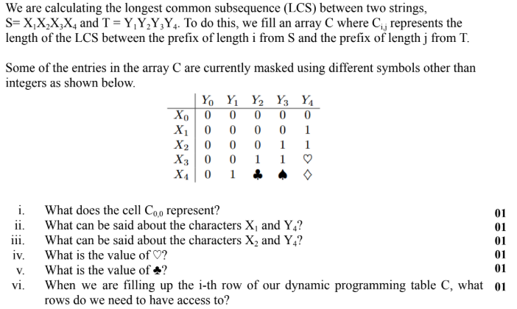

- The white council once decided to install bidirectional rail tracks to connect several realms of middle
earth. Upon their request, the elves and the dwarves devised a plan. The following table lists the tracks that can be constructed.
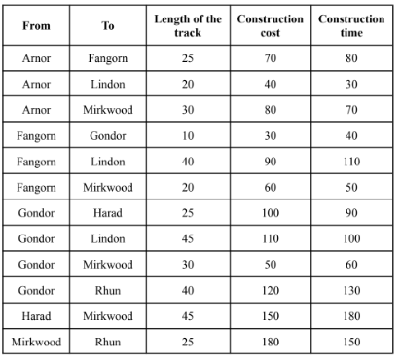
As there is only one engine available for the task, simultaneous construction of multiple tracks is not
possible. Going through the plan, the council decided that the following tracks must be constructed.
● Mirkwood to Rhun
● Fangorn to Lindon
However, due to a financial crisis, the council wants to connect all the realms with minimum total
construction cost. Now answer the following questions.
a) Which other tracks should they select for construction? Show a simulation of your procedure. Write the total construction cost of the selected tracks. [5]
b) Calculate the total construction time required if no two tracks are constructed simultaneously. [1]

